**COGS 536 Homework 3**

**Ayse Ozdemir - 2340008**

**1.**

Independent variables: **Pattern Type**(Has 4 level: Face, Circle, Newspaper, White)

Dependent variables: Measured ***length of gaze***(in sec) of an infant at a particular target

Research Hypothesis: There **is** **statistically significant difference** between the measured length of gazes (in sec) of an infant at different targets.

**One Way Anova**, **Repeated Measures**

One Way Anova because; we are manipulating more than 2 independent variables. In this case our independent variable is measured length of gaze(in sec), which has 4 levels(Face, Circle, Newspaper, White).  
 Repeated Measures because; same participants are taking part in all parts of the experiment(same person are being repeatedly measured on various conditions).

1. Question1.sav is under my homework file.
2. **Assumptions of Anova:**   
   Dependent variable is measured at least at the interval scale   
   Data points within experimental groups are normally distributed  
   Homogeneity of variance (Levene’s test)  
   Variances among experimental groups are similar  
   Observations should be independent

**SPSS – ‘Test of Normality’ Results:**  
In the following part, SPSS test results could be seen, explanations of the graphs could be seen at the end of the results.

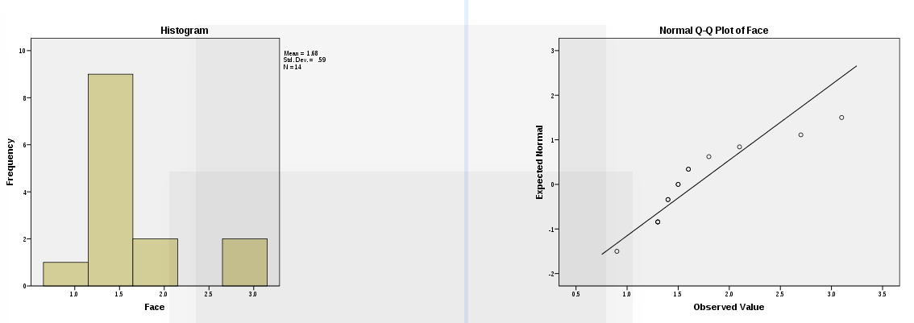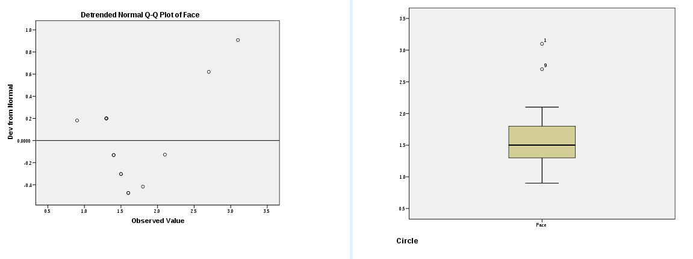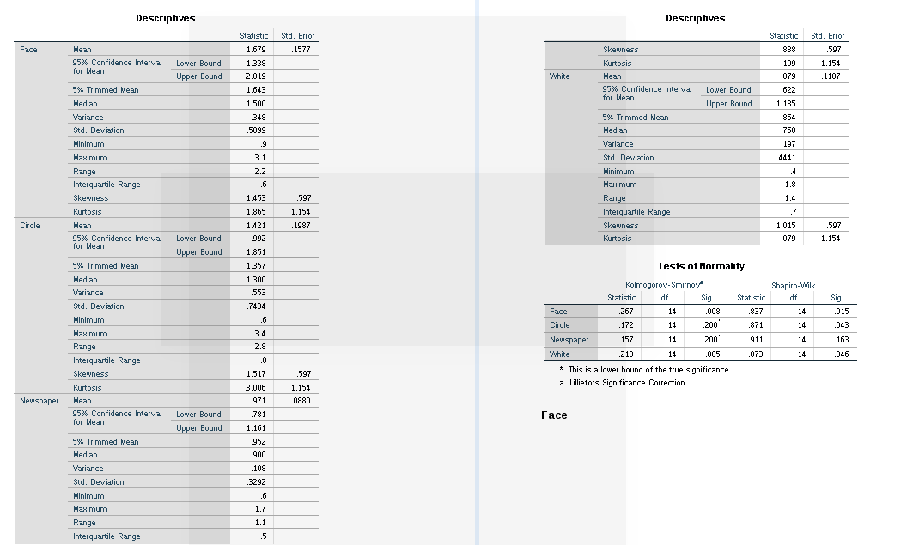

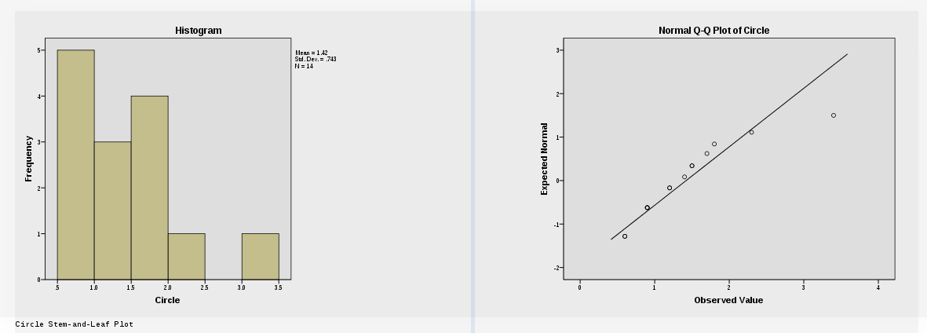

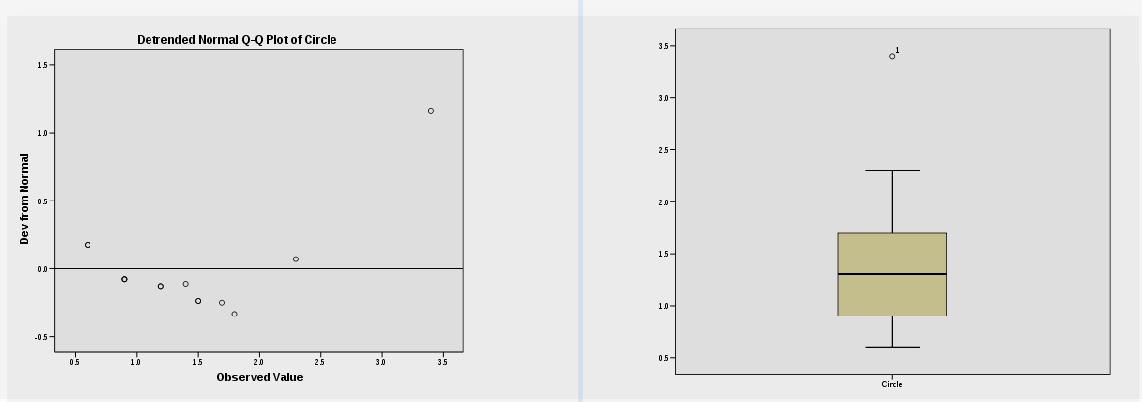

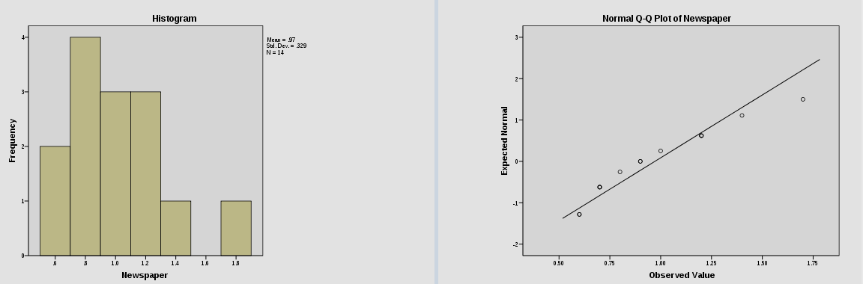

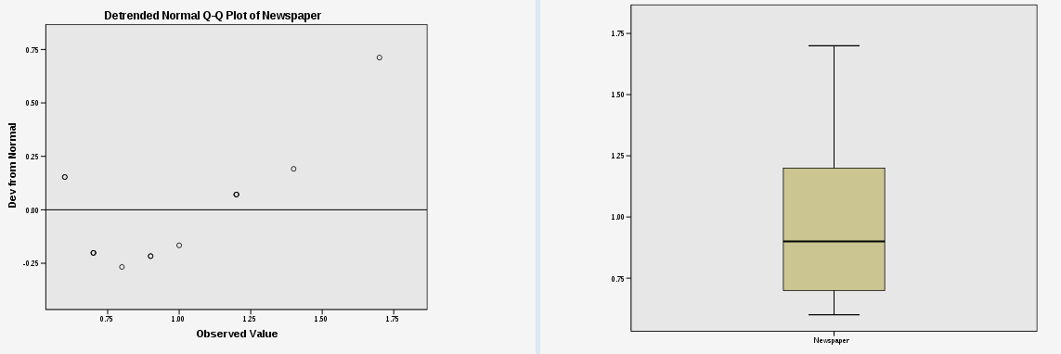

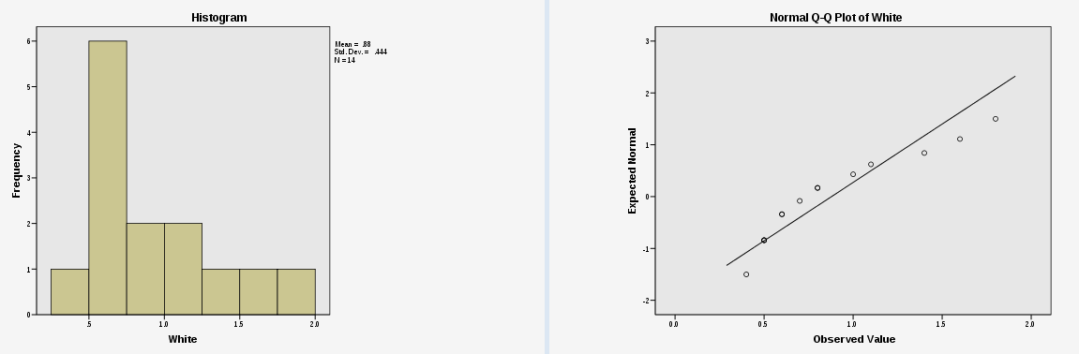

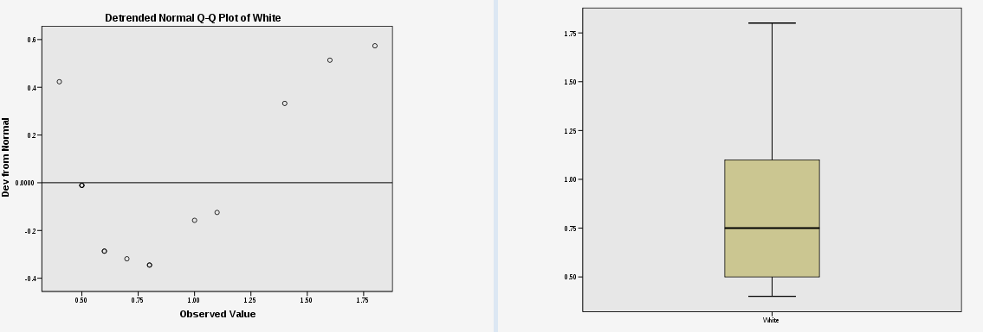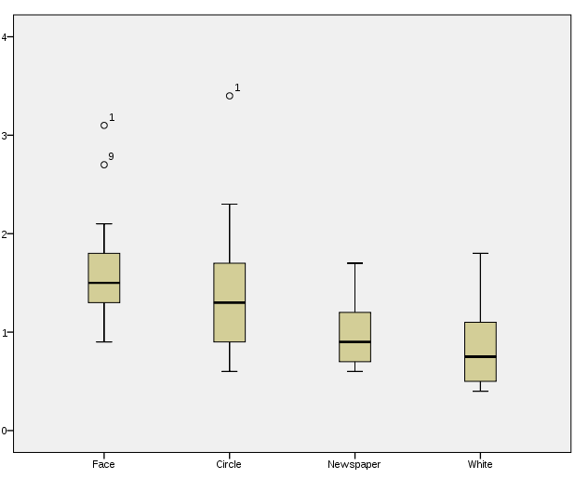

**Shapiro-Wilk Test Results:**  
  
For the Face variable : W(14) = .837, p<0.05 => Face is significantly non-normal  
For the Circle variable : W(14) = .871, p<0.05 => Circle is significantly non-normal

For the Newspaper variable : W(14) = .911, p>0.05 => Newspaper is significantly normal

For the White variable : W(14) = .873 , p<0.05 => White is significantly non-normal  
  
Although Shapiro-Wilk test results, seems to tell that data is not normally distributed. We check other graphs like Histogram, Q-Q plot, and Box-plots (**Each box-plot is roughly simetrical, this confirms each group is aproximately normal**)

When we combine all the results; and considering data also contains outliers(can be checked from box-plots), data can be counted **approximately normal.**   
  
  
**SPSS – ‘Homogeneity of Variance – Levene’s Test’ Results:**  
In the following part, SPSS test results could be seen, explanations of the graphs could be seen at the end of the results.

Levene’s test. (p>0.05 , assumption of homogeneity of variance is tenable)

Levene’s test, tests variances in different groups.

Significant = Variances not equal

Non-Significant = Variances are equal

1. 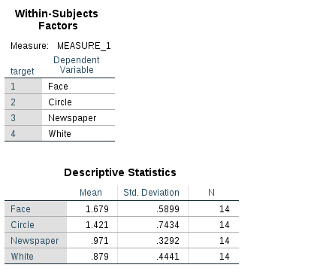  
     
   Results of One Way Repeated Measures Anova:

In the results above; four level of independent variable can be seen(Face, Circle, Newspaper, White)  
According to the results; mean value and standart deviation of Face and Circle has a higher value compared to other 2 targets.

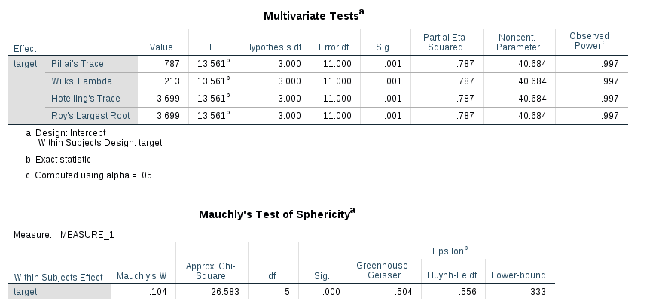  
  
  
  
  
  
  
  
  
  
  
  
**According to the Mauchly’s test;** as **p<0.05**, this is a significant result and, the **assumption of Sphericity is violated.**

Fortunately, SPSS has a few corrections that we can use in the case of violation of sphericity. One of them is Greenhouse-Geisser and the other one is Huynh-Feldt. As the Epsilon values in the previous table is less than .75, we would interpret the **Greenhouse-Geisser correction which has p values less than 0.05.**

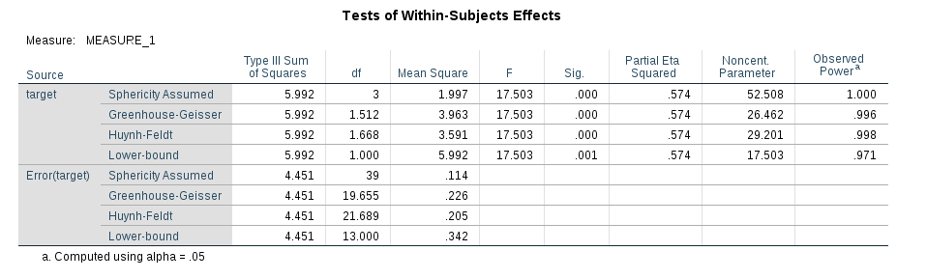

Significance of F is **is significant** as it is less than the criterion value of .05. We can, therefore, conclude that there was a significant difference between the length of gaze of an infant at four different targets. However, this main test does not tell us which length of gaze of an infant at a particular target differed from each other.

As our data violated the assumption of sphericity, we look at the values in the "Greenhouse-Geisser" row. We can report that when using an ANOVA with repeated measures with a Greenhouse-Geisser correction, the mean scores were statistically significantly different (F(1.512, 19.655) = 17.503, p< 0.0005).

Kitabin sf 477 sine tekrar bak eksik mi diye  
yukardaki sonuclari spss veriyor.

Total I elle hesapla, within I cikarip, between I elle bulabiiriz.  
Tablo olusturup , tabloyu doldur.

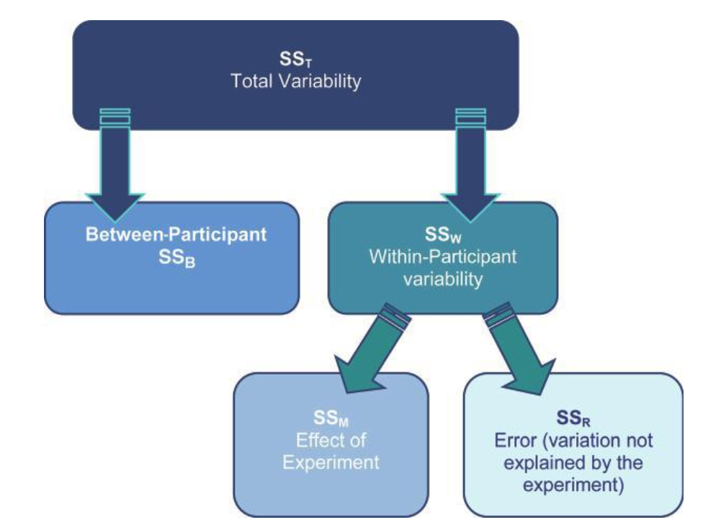

1. Anova result **is significant** as it is less than the criterion value of .05. We can, therefore, conclude that there was a significant difference between the length of gaze of an infant at four different targets.

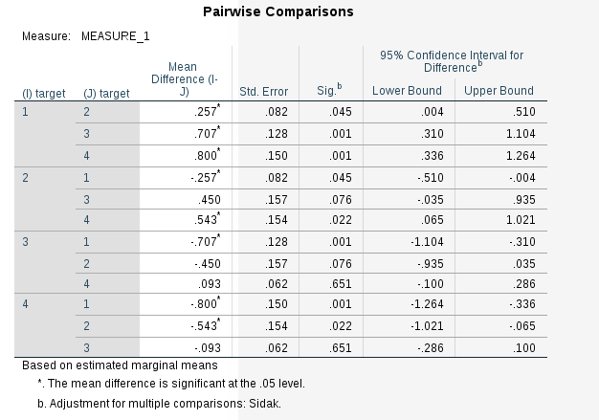  
  
  
  
  
  
  
  
  
  
  
  
  
  
  
  
  
  
  
  
  
 1-face, 2-circle, 3-newspaper, 4-white

Looking at the table above, this table gives us the significance level for differences between the individual measured times on different targets. We can see that there was a significant difference in measured time between face and newspaper (p<0.05), and between circle and white(p<0.05), and between white and face(p<0.05). From the Mean Difference column, we can also see the differences between two means.

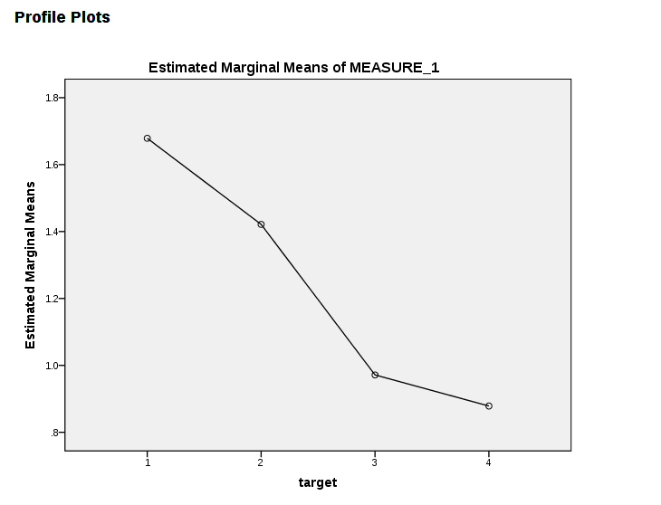

1. 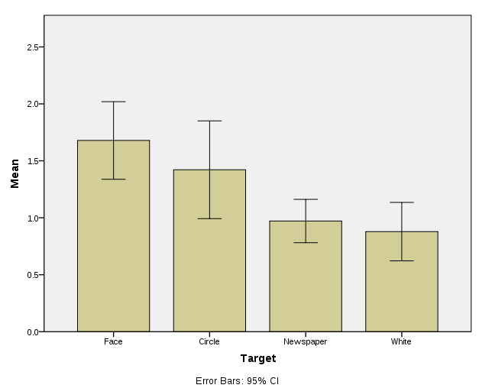

The bar charts show the mean values of Face and Circle scores together with 95% CIs. Since there is considerable overlap among the CIs, there does not seem to be a significant difference among this 2 groups(Face and Circle).  
In the same way; Newspaper and White scores together with 95% CIs. Since there is considerable overlap among the CIs, there does not seem to be a significant difference among this 2 groups(Newspaper and White).

1. A one-way repeated measures ANOVA was conducted that examined the effect of different targets on the length of gaze (in sec) of an infant at a particular target.

There is a significant difference between the length of gaze of an infant at four different targets.   
  
As our data violated the assumption of sphericity, we look at the values in the "Greenhouse-Geisser" row. We can report that when using an ANOVA with repeated measures with a Greenhouse-Geisser correction, the mean scores were statistically significantly different. **F(1.512, 19.655) = 17.503, p< 0.0005)**.

**2.**

1. Independent variables: **Age Group**(Has 3 level:7-Months-Olds, 10-Months-Olds, 13-Month-Olds), **Gender**(Has 2 level:Girls, Boys)

Dependent variables: Measured(rated) time proportion  
Research Hypothesis: There **is** **statistically significant difference** between the proportion of time parents encouraged pretend play in different groups of children in terms of age and gender.

1. **Two Way Independent**(factorial) **Anova**Two Way ANOVA compares the mean differences between groups that have been split on two independent variables(age group, gender). There is one dependent variable, measured(or manipulated) according to the two independent variables.  
     
   Independent: Different participants in all conditions
2. Question2.sav is under my homework file.

1. 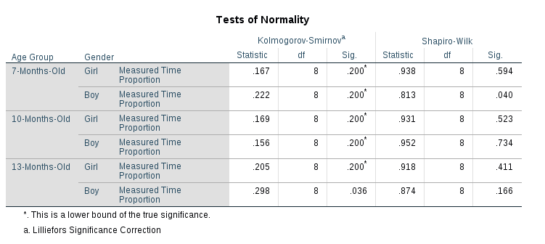

Because the small sample size, Shapiro-Wilk will have higher power as a test of normality, so you could rely on this test.

All variables except 7-Months-Old Boy are normally distributed according to the Shapiro-Wilk tests reported in the table above.   
  
Shapiro-Wilk test indicated that;  
7-Months-Old measure times for Girls are normally distributed, S-W(8)=.93, p>.05  
7-Months-Old measure times for Boys are normally distributed, S-W(8)=.81, p>.05

10-Months-Old measure times for Girls are normally distributed, S-W(8)=.93, p>.05  
10-Months-Old measure times for Boys are normally distributed, S-W(8)=.95, p>.05  
  
13-Months-Old measure times for Girls are normally distributed, S-W(8)=.91, p>.05  
13-Months-Old measure times for Boys are normally distributed, S-W(8)=.87, p>.05  
  
**As a result: assumption of Normaly Distribution of the data is met.**

We also check Homogeneity of Variance as it is an assumption of Anova. EKSIK

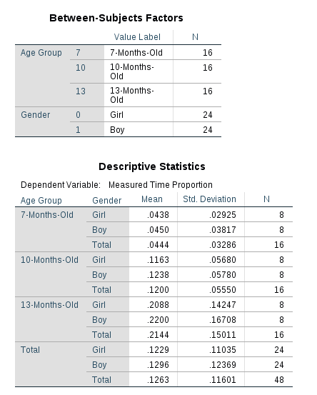

The plot of the mean "Measured Time Proportion" score for each combination of groups of "Gender" and "Age Group" are plotted in a line graph. According to this graph, we might expect there to be a statistically significant interaction.

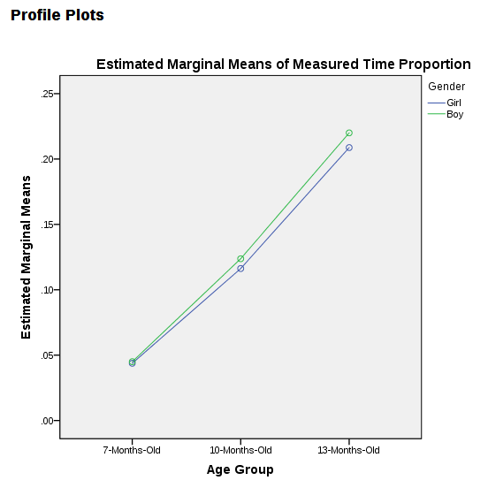

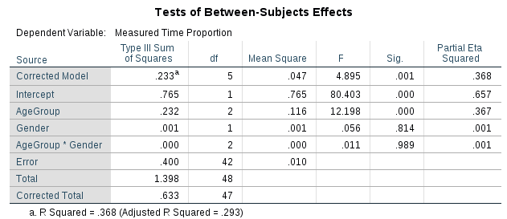

From the table above, we can see whether either of the two independent variables or their interaction are statistically significant.  
  
Tests of Between Subjects Effects table informs us whether our independent variables (the "Gender" and "Age Group") and their interaction (the "AgeGroup*Genderl") have a statistically significant effect on the dependent variable, "Measured Times".

When we look at the AgeGroup*Gender row, we have a statistically significant interaction at the p = 0.01.

We can see from the table above that there was **no statistically significant difference in measured time between girls and boys** (p = .814 => p > .05), but there **were** **statistically** **significant** **differences** between measured time and different Age Groups (p < .05).

1. 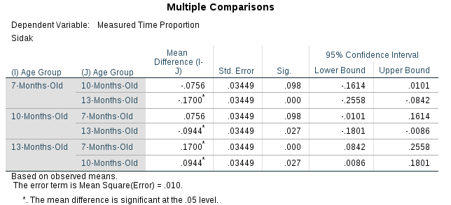  
     
   We can see from the table above that there was **no statistically significant difference in** measured timebetween **girls and boys** (p = .814 => p > .05), but there **were statistically significant difference** in measured time between different **Age Groups** (p < .05).

From the results, we can see that there is a statistically significant difference between 7-Months Old and 13-Months old(p<0.05), between 10-Months old and 13-Months-Old(p<0.05)

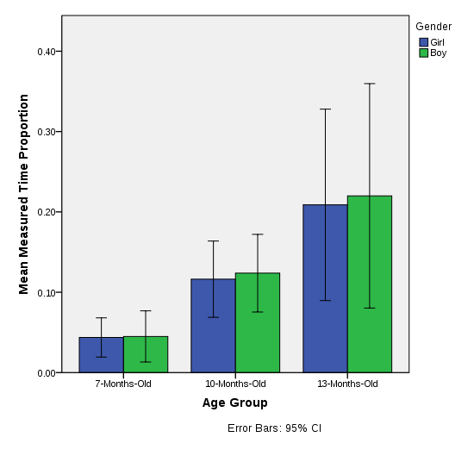  
  
  
  
  
  
  
  
  
  
  
  
  
  
  
  
  
  
  
  
  
The bar charts show the mean values of each group’s measured times group by gender and age group.

Since there is considerable overlap among the Cis between boys and girls, we can say that there does not seem to be a significant difference between genders.

When we consider age groups in the same way, as there is not considerable overlap among age groups, we can say that there is a significant difference between age groups.

1. A two-way ANOVA was conducted that examined the effect of Gender and Age Group on  
   proportion of time parents encouraged pretend play in their children. There was a statistically significant interaction between the effects of gender and Age Group on measured time, F(2,42)= 0.11, p = 0.11